Investigating the neural control of social behavior in Drosophila melanogaster using a low-cost optogenetics system.

Eric D. Hoopfer¹, Aaron Heidgerken-Greene²

¹Neuroscience Program, ²Department of Physics and Astronomy,
Carleton College, Northfield, MN, 55057

Running title: Exploring social behavior in flies with optogenetics

Key words: optogenetics; Drosophila; social behavior; aggression; courtship

ABSTRACT
Optogenetics offers a powerful tool for students to explore how neural circuits generate behavior. Here we introduce a lab module using Drosophila to help students understand the principles of optogenetics through the study of social behaviors such as aggression and courtship. In this activity, students used the red-shifted opsin CsChrimson to activate P1 neurons—key regulators of male courtship and aggression. They observed that P1 activation elicits courtship in the absence of appropriate sensory cues and induces a persistent internal state that enhances aggression or courtship depending on social context, illustrating how a single neuronal population can regulate opponent behaviors and internal states. We implemented this module using FlyRig, an inexpensive, modular, open-source system we developed that provides precise light stimulation and synchronized video recordings suitable for automated tracking and classification tools. This lab module introduces students to the principles of optogenetics, experimental design, and quantitative behavior analysis, and provides a framework for exploring the neural basis of social behaviors and the internal states that drive them. Assessment of student experiences supports the utility of this lab activity in enhancing understanding of conceptual and experimental methods for studying neural control of behavior with optogenetics, as well as the usability of the FlyRig system for behavioral experiments.
INTRODUCTION
Optogenetics has transformed the study of the neural basis of behavior by enabling precise, temporally controlled manipulation of genetically defined neuronal populations using light (Deisseroth, 2011). This technique involves expressing light-sensitive microbial opsins in targeted neurons, allowing neural activity to be modulated in awake, behaving animals. For example, channelrhodopsin, a light-gated cation channel originally isolated from the green alga Chlamydomonas reinhardtii (Nagel et al., 2003), depolarizes neurons in response to blue light (Boyden et al., 2005). Optogenetics enables millisecond-scale control of neural activity, facilitating causal investigations of how specific neural circuits contribute to behavior, perception, and neurological or psychiatric disorders (Fenno et al., 2011).

Drosophila melanogaster offers many advantages for implementing optogenetics in an undergraduate classroom setting due to its extensive genetic toolkit, which allows for optogenetic manipulation of specific neural circuits using simple genetic crosses. In Drosophila, the GAL4/UAS binary expression system is used for targeted expression of transgenes in defined neuronal populations (Brand and Perrimon, 1993). This system uses cell-specific promoters to drive expression of the yeast transcriptional activator GAL4, which binds to the upstream activating sequence (UAS) to initiate transcription of a gene of interest. A large, publicly accessible collection of GAL4 driver lines (Jenett et al., 2012; Dionne et al., 2018) is available for targeting specific circuits, as are a range of UAS-opsins transgene lines for neuronal activation (Pulver et al., 2009; Klapoetke et al., 2014) or inhibition (Mohammad et al., 2017). Many of these tools are available at little to no cost through the Drosophila research community and the Bloomington Drosophila Stock Center. In addition, open-source tools for automated fly tracking and behavior scoring (Kabra et al., 2013; Eyjólfsdóttir et al., 2014; Pereira et al., 2019) provide an unbiased and reproducible means of analyzing behavioral data across student groups, facilitating collaborative inquiry. These features make Drosophila an ideal system for implementing hands-on, inquiry-based neuroscience activities using optogenetics to help students understand how neural circuits give rise to behavior.

Red-shifted opsins such as CsChrimson, which are activated by red light that readily penetrates the adult cuticle (Inagaki et al., 2013; Klapoetke et al., 2014), make it possible to perform optogenetic experiments in freely behaving adult Drosophila. This expands the range of behaviors accessible for study in teaching labs and avoids the need for invasive preparations. Undergraduate lab courses have leveraged this approach to examine the neural control of escape responses, locomotion, and gustatory perception (Titlow et al., 2015; Vilinsky et al., 2018; Fu et al., 2023). Here, we describe a lab activity that uses Drosophila optogenetics for students to investigate the neural basis of social behaviors—specifically, male aggression and courtship. These behaviors consists of a stereotyped set of actions (Hall, 1994; Chen et al., 2002) that students can quickly learn to recognize, and which can be scored with machine-learning-based classifiers (Dankert et al., 2009; Kabra et al., 2013; Chowdhury et al., 2021; Yadav et al., 2025). Recent work has advanced our understanding of the neural circuits that underlie male aggression and courtship, including the sensory inputs that trigger them, motor pathways that produce them, and neuromodulatory systems that regulate internal states like motivation and arousal (Auer and Benton, 2016; Hoopfer, 2016; Lee and Wu, 2020). This well-studied circuitry provides an excellent framework for helping students understand how specific neuronal populations generate complex behaviors.

A key node in the circuitry that regulates male social behavior is the male-specific P1 neuron population, which integrates female sensory cues and promotes courtship and aggression. Optogenetic activation of P1 neurons elicits male courtship behaviors such as wing song, even in the absence of females (Bath et al., 2014; Inagaki et al., 2014). In addition to triggering immediate behavioral responses, P1 activation also induces a persistent internal state of social arousal that promotes aggression and courtship depending on social context (Hoopfer et al., 2015; Jung et al., 2020). Thus, optogenetic activation of P1 neurons can provide students with a compelling demonstration of how neural circuits mediate both acute behaviors and longer-lasting, state-dependent behaviors.

A major barrier to implementing optogenetics in the classroom is the cost of research-grade equipment, which typically includes machine vision cameras, optomechanical parts, and other expensive components (Inagaki et al., 2013; Robie et al., 2017). To address this, we developed FlyRig, an affordable, open-source platform that combines optogenetic stimulation with synchronized video acquisition. Each setup costs around $350 to build, supports parallel recording of multiple flies, and is compatible with widely used computational tools for automated tracking and behavior scoring, such as FlyTracker (Eyjólfsdóttir et al., 2014) and JAABA (Kabra et al., 2013). The system can be constructed and operated with minimal technical expertise, making it accessible to instructors and students alike. FlyRig complements existing low-cost solutions for fly optogenetics (Pulver et al., 2011; Chagas et al., 2017; Tadres and Louis, 2020) by enabling simultaneous recording of multiple fly pairs with software that runs on standard desktop operating systems.

Here, we describe a neuroscience laboratory module in which students use FlyRig to investigate the neural basis of social behavior in Drosophila through optogenetics. Students activate P1 neurons with CsChrimson and assess the effects on male courtship and aggression, illustrating how neural circuits regulate behavior on different time scales and integrate external cues to generate flexible behavior. The activity reinforces core neuroscience concepts, including neural circuit function, internal states, and molecular genetic techniques for modulation neural activity, while providing hands-on experience in hypothesis testing, experimental design, and quantitative behavioral analysis. By combining affordability with ease of use, FlyRig reduces barriers to incorporating optogenetics into undergraduate neuroscience curricula.

MATERIALS AND METHODS
Instructional materials, including lab protocols, scoring guides, example videos, an instructor guide, and complete build and operation instructions for the FlyRig system, are provided in the Supplemental Materials.

Implementation of Lab Activity
This optogenetics lab exercise was implemented as part of the laboratory component of Foundations in Neuroscience, an introductory course at Carleton College with no prerequisites and a typical enrollment of 30–40 students. The primary learning goals of the lab activity were to introduce the principles of optogenetics, deepen students’ understanding of how neural activity gives rise to complex behaviors, quantifying and interpreting animal behavior, and provide experience designing experiments to test hypotheses about neural circuit function.

Before the lab, students were introduced to gene expression, neuronal cell biology, and electrical and chemical signaling through in-class units. As pre-lab work, students watched videos on optogenetics (Nature Video - Method of the year 2010: Optogenetics), and how to use the FlyRig system (Supplemental Materials), and completed a pre-lab quiz. After the lab activity, students had a week to complete a post-lab written assignment in which the produce a graph and figure legend of their results and write a summary of the results. For additional context about how this laboratory fits into the lab course, we include the lab syllabus in the Supplemental Materials.

The lab activity began with a 30-minute lecture reviewing the principles of optogenetics and the use of Drosophila melanogaster as a model for studying social behavior. Students then spent approximately 30 minutes learning to recognize a subset of male aggression and courtship behaviors (Table 1). They reviewed written descriptions and example video clips of each behavior. They then practiced identifying these behaviors in videos of male-male pairs where neurons previously shown to elicit male social behaviors are being thermogenetically activated with dTRPA1 (Hoopfer et al., 2015). The video set included one line that selectively promoted wing threat (Line 1), one that triggered the full repertoire of aggressive behaviors (Line 2), one that evoked wing extension oriented toward the other fly (Line 3), and one that elicited undirected wing song (Line 4). After scoring the videos, students compared their results to ground-truth annotations and discussed their observations as a class to build consistency in behavioral identification.

In the main component of the lab (2-3 hours), students worked in small groups (3–4 students) each with their own FlyRig system. For a class of ~30–40 students, one photostimulation rig per 5–6 students allow multiple groups to work in parallel while keeping costs manageable and minimizing bottlenecks in the lab workflow. Students were asked to characterize the behaviors elicited by optogenetic activation of P1 neurons, without prior instruction about the role of these neurons in male social behavior. The goal was for students to generate conclusions from their experiments about how P1 neurons regulate courtship and aggression. To become familiar with the FlyRig system, each group first conducted a 20-minute pilot experiment, observing the behaviors of solitary males from each genotype in response to light pulses at different frequencies. After a class discussion, students selected a stimulation protocol (1 minute of 30 Hz pulsed light) and then tested both solitary males and male pairs from each genotype. Students manually scored the number of lunges and wing extensions during light-on and light-off periods, graphed their results, and presented preliminary findings to the class. Based on these initial observations, each group formulated a hypothesis regarding P1 neuron function in male social behavior and designed a follow-up experiment to test it.

FlyRig equipment and software
The FlyRig system consists of three main components: the photostimulation rig (Figure 1), the LED/backlight circuit board (Figure 2), and integrated software (Figure 3). Building and operating the system requires basic electronics assembly tools (e.g., soldering iron), access to a laser cutter, and a computer to run the FlyRig software and store video recordings.

The photostimulation rig (Figure 1A) consists of a frame into which light, diffuser, and camera plates are inserted. The parts were laser cut from the following materials: frame panels (3/16” thick nominal plywood), light and camera plates (0.125” clear acrylic; McMaster-Carr 8560K191), and diffuser plate (0.125” white Delrin; McMaster-Carr 8573K13). The frame can also be cut from 0.2” acrylic or Delrin to aid in cleaning. Laser-cut parts can be fabricated using local makerspaces, university facilities, or small commercial services that accept CAD files for custom orders (e.g., Ponoko.com). However, no specific vendor is required, allowing flexibility based on availability and cost.

High-intensity deep red LEDs (655nm wavelength, Luxeon Star LEDs SR-05-D0000) were mounted on the light plate for photostimulation, along with strips of 850nm IR LEDs (ledlightsworld.com 5M-HK-8MM-F3528-850-30-NW-IR-12) to visualize fly behavior (Figure 1B). The fly behavior chamber (Figure 1C) was placed on the diffuser plate, and fly behavior was recorded using a mini-USB camera with a 2.8-12mm zoom lens (ELP ELP-USBFHD06H-FV) mounted on the camera plate. A long-pass IR filter (B&H Camera 87CP3) was affixed to the lens to block light from the high-intensity LEDs.

We adapted the LED control circuit from Pulver et al. (2011) and Inagaki et al. (2013), and mounted all components on a custom-printed circuit board (PCB; JLCPCB.com; Figure 2). Design files for the PCB and instructions for assembling the circuit on a standard breadboard are available for download (Supplemental materials). A Metro Mini microcontroller, controlled by Arduino code, regulates both the timing and intensity of photostimulation. To control the stimulation LEDs, the microcontroller sends digital commands via the I²C (Inter-Integrated Circuit) protocol to a digital-to-analog converter (DAC), which outputs a 0–5V analog control voltage. This analog signal drives an externally dimmable constant-current LED driver (Buckpuck 3021-D-E-700; maximum output 700 mA), powered by a 12 V DC supply. For the infrared (IR) backlight LEDs, brightness is modulated independently using a 5V PMW signal from the microcontroller to a field-effect transistor (FET) configured as a low-side switch. This setup enabled real-time adjustment of IR illumination to optimize video contrast and image quality. To mark the timing of light stimulation in video recordings, we mounted an additional IR indicator LED near the behavioral chamber. A separate digital output from the microcontroller, synchronized with the stimulation protocol, controlled the indicator LED, providing a visible timing reference in the recorded footage. We also developed an expanded version of the PCB capable of driving four sets of LEDs and eight solenoid valves independently (Supplemental Materials).

FlyRig software (Figure 3) was developed in JavaScript using Electron (electronjs.org) and Node.js (nodejs.org), and runs on both Windows and macOS operating systems. It features an integrated graphical user interface for controlling LED activation (manually or automatically) and IR lighting, logging experimental metadata, and recording videos in h264 mp4 format. The GUI can be used to record video without the circuit board connected. To facilitate classroom use, a precompiled executable version is available for Windows, allowing the software to be run without installation or code modification.

Fly stocks
The following fly stocks were used: pBDPGAL4U (BDSC #68384; Pfeiffer et al., 2010), R15A01-p65.AD(attP40);GMR71G01-GAL4DBD(attP2) (referred to as P1a in text; Hoopfer et al., 2015), 20XUAS-IVS-CsChrimson.mVenus(attP2) (BDSC #55136; Klapoetke et al., 2014). We are happy to provide all stocks on request. Fly stocks were maintained at room temperature (21-25ºC) in bottles with Jazz-Mix Drosophila Food (Fisher, AS153) and transferred to fresh bottles every 2 weeks.

Optogenetic experiments
For optogenetic experiments, GAL4 males were crossed with UAS-CsChrimson virgin females in vials containing fly food supplemented with 0.4 mM all-trans-retinal (Sigma-Aldrich, #R2500). Crosses were maintained in constant darkness at 25°C and 50–60% humidity, with parents transferred to fresh retinal food vials every 3–4 days. Male progeny were collected 0–2 days post-eclosion and housed in groups of 15–20 flies per vial for 6–7 days on retinal food under constant darkness. Flies were transferred to fresh retinal food vials one day before behavioral experiments.

Optogenetic experiments were conducted as described in Hoopfer et al. (2015). Experiments took place in an acrylic behavior chamber consisting of 12 cylindrical arenas, each measuring 12 mm in height and 16 mm in diameter (Figure 1C). A thin layer of food (apple juice with 2.5% sucrose and 2.25% agar) was applied to the bottom plate to stimulate aggression (Lim et al., 2014). Arena walls were coated with Fluon (PTFE-30; Tarheel Ants), and the top plate was treated with Sigmacote (Sigma, SL2) to prevent flies from climbing. The diffuser plate was positioned approximately 4 cm above the light plate. The irradiance measured with an optical power meter (Thorlabs, PM160) with constant light is approximately 0.07mW/mm². Single males or male pairs of the same genotype were loaded into the chambers via aspiration and allowed to acclimate for 5 minutes. Experiments were conducted at room temperature under ambient lighting conditions. Behavior was recorded at 30 frames per second with a resolution of approximately 25 pixels/mm.

Behavioral analysis and statistics
Student-generated movies were processed after class using Caltech FlyTracker (Eyjólfsdóttir et al., 2014), which tracks body and wing positions, and JAABA-based classifiers (Kabra et al., 2013; Hoopfer et al., 2015) to identify bouts of lunging and unilateral wing extension (i.e., wing song). Statistical analyses were conducted in MATLAB. Mann-Whitney U tests were used to compare behaviors between genotypes. Statistical significance was defined as α < 0.05.

Student survey
After the laboratory activity, students were asked to complete an attitudinal survey regarding the conceptual and technical aspects of the activity. Completion of the survey was optional, and no personal identifying information (gender, class, year, major, etc.) was collected as part of the survey. The study was reviewed and approved (exemption granted) by the Institutional Review Board of Carleton College.

RESULTS

Optogenetic stimulation of P1 neurons in male flies
Students investigated the role of P1 neurons in controlling male social behavior by optogenetically stimulating P1ª neurons—a subset of 8–10 neurons in the P1 cluster previously shown to regulate male courtship and aggression (Hoopfer et al., 2015). Working in groups, students addressed two questions: (1) What behaviors are promoted during and after neuronal stimulation? and (2) Does the presence of another male alter these behaviors? Behavioral responses of P1ª/CsChrimson males (referred to as P1ª) were compared to genetic control males (BDPG4U/CsChrimson, referred to as BDPG4U) (Pfeiffer et al., 2010) that do not express GAL4 in the nervous system. Students manually scored wing extensions (courtship) and lunges (aggression) during class, and student video recordings were later processed by the instructor for automated analysis of the same behaviors (Figure 4).

To characterize the behaviors elicited by P1ª activation, students first tested solitary males. Compared to genetic controls, P1ª males exhibited a significantly elevated rate of unilateral wing extension both during and after photostimulation (Figure 4A). Students then repeated the assay using pairs of males to assess the influence of social context on P1ª-evoked behaviors. As in the solitary condition, wing extension was significantly elevated during the stimulation period relative to controls (Figure 4B). However, unlike single males, P1ª pairs exhibited a marked increase in lunging following stimulus offset, indicating a transition from courtship to aggression in the post-light period (Figure 4B).

Based on these observations, students developed hypotheses about how P1 neurons regulate male social behavior. One class of experiments tested whether the behaviors displayed depended on the activation threshold of P1 neurons, varying the intensity or frequency of light stimulation. A second class of experiments examined whether persistent post-stimulation behaviors resulted from a fly-intrinsic change (i.e., an altered internal state) or from external influences. For example, students tested whether a P1a/CsChrimson male would still display aggression toward a non-aggressive BDPG4U/CsChrimson male to determine whether sustained aggression was due to escalating attack-counterattack cycles between two P1ª-activated males (i.e., social feedback). In summary, P1ª activation produces robust, context-dependent behavioral phenotypes that students used as a basis for designing follow-up experiments, providing additional practice in experimental design, data analysis, and interpretation while reinforcing their understanding of how neural circuits control behavior.

Student Feedback
We conducted a voluntary survey of students enrolled in two sections of our introductory neuroscience laboratory course (n = 17 responses; response rate = 53%) to evaluate their perceptions of both the pedagogical and technical components of the lab activity (Table 2). The majority of respondents agreed that the lab enhanced their understanding of how channelrhodopsin is expressed in specific neurons and how it functions to elicit action potentials. Students also reported increased confidence in formulating hypotheses about the neural control of behavior and in designing experiments to test these hypotheses. On the technical side, students found it straightforward to record videos and control light stimulation using the FlyRig system, and generally agreed that the system functioned reliably. One group reported difficulty connecting to the camera; however, this was resolved by unplugging and reconnecting the device to reset the USB port. Overall, students found the FlyRig software easy to use for conducting experiments.

DISCUSSION
Optogenetics is a widely used tool in neuroscience, making it important for students to gain direct experience with its principles and applications. Drosophila melanogaster offers an accessible platform for optogenetics in teaching laboratories and has been used to introduce students to synaptic physiology and the neural basis of behavior (Pulver et al., 2011; Titlow et al., 2015; Vilinsky et al., 2018; Fu et al., 2023). This lab activity extends these approaches by engaging students in circuit-level investigations of social behaviors, specifically aggression and courtship, which are shaped by sensory cues from conspecifics, prior social experience, and internal states (Lee and Wu, 2020; Jiang and Pan, 2022; Schretter, 2025). These features make them a rich model for exploring how neural circuits regulate complex behaviors while reinforcing core concepts in optogenetics, genetic targeting of specific neurons, and hypothesis-driven experimental design. Post-lab surveys indicated that the activity enhanced student understanding of both the conceptual basis and experimental methods for studying neural control of behavior using optogenetics.

Optogenetic activation of P1ª neurons produces a robust and easily recognizable phenotype that can be used to illustrate various concepts related neural circuit control of behavior. Students observe that stimulation of P1ª neurons triggers courtship even without appropriate sensory cues (e.g., no female present or even the presence of a male), demonstrating that P1 neuron activity is sufficient to initiate courtship behavior. The persistence of behavior after stimulation prompts students to consider whether P1 neurons induce internal states, such as arousal, motivation, or drive, that sustain behavior over time (Berridge, 2004; Anderson, 2016). Finally, the differences in post-activation behavior that depend on social context (courtship when alone, aggression in the presence of another male) illustrate how external cues are integrated with internal states to shape behavioral output (Kennedy et al., 2014). These observations help students understand how neural circuits orchestrate behavior across different time scales and social contexts, while providing a foundation for generating and testing new hypotheses.

This lab activity can be modified in several ways to fit different purposes. We have used this activity for a 2-hour summer high school program by omitting the experimental design module at the end. In this shortened version, students still learn about optogenetics, observe it in action, and learn to interpret neural gain-of-function experiments and develop hypotheses about how neurons control behavior. Conversely, there are several ways to expand the activity. First, although the instructor processed student videos in the activity described here, students can readily perform automated behavior scoring and statistical analyses themselves. Incorporating this step provides valuable training in coding, image analysis, and quantitative data interpretation, particularly in courses where MATLAB or other analysis software is available. To support this, we provide instructions and code for video processing, fly tracking, and automated behavior scoring (github.com/flyRig). Second, this module can be extended into a Course-Based Undergraduate Research Experience (CURE). For example, in our introductory neuroscience course, students spend the final four weeks of the term building on this experiment by designing and conducting a research project investigating P1 neuron function in social behavior. Past projects have explored how neuromodulators such as dopamine shape P1-induced courtship and aggression, whether P1 activation is rewarding to male flies, and how internal states such as hunger, sleep deprivation, or stress influence P1 excitability. Third, studying the neuronal basis of social behaviors such as aggression and courtship encourages students to view these behaviors through a biological lens. Post-lab assigned readings such as Anderson & Adolphs (2014), which provides an accessible overview of how emotions can be studied in animals, can help students connect their findings to broader concepts in neuroscience and psychology.

Recent advances in mapping the neural circuits underlying Drosophila social behavior in both sexes (Auer and Benton, 2016; Asahina, 2018; Oren-Suissa and Shirangi, 2025; Schretter, 2025) provide additional opportunities for classroom experiments on aggression and courtship. Several GAL4-based driver lines available from the Bloomington Drosophila Stock Center target neurons that promote specific behaviors upon activation. For example, TK5fa-GAL4 (BDSC#51975) promotes male aggression (Asahina et al., 2014), 26E01-GAL4 (BDSC#60510) promotes female aggression (Palavicino-Maggio et al., 2019), and 60G08-GAL4 (BDSC#39260) promotes aggression in both sexes (Chiu et al., 2021). Other lines target specific aggressive behaviors, such as 20E08-GAL4 (BDSC#59851), which elicits wing threat (Duistermars et al., 2018). For courtship, fru-GAL4 (BDSC#66696) labels ~2,000 neurons in the male brain and promotes multiple courtship actions (Pan et al., 2011; Inagaki et al., 2013), while 22D03-GAL4 (BDSC#49871) promotes wing song (Robie et al., 2017). By selecting different driver lines, instructors can tailor the module to target a variety of social behaviors, broadening the range of experimental questions students can explore.

FlyRig system
FlyRig builds on earlier low-cost systems (Pulver et al., 2011; Vilinsky et al., 2018) by integrating software that enables students to easily adjust light stimulation parameters and timing, record videos and experimental metadata, and test multiple fly pairs simultaneously. The resulting data are compatible with automated behavior scoring tools such as FlyTracker and JAABA, facilitating quantitative analysis of student-generated data. JAABA-based classifiers for several male aggression and courtship behaviors (Chowdhury et al., 2021; Yadav et al., 2025) are already available and can be used with this system. Compared to other systems such as PiVR (Tadres and Louis, 2020) and FlyPi (Chagas et al., 2017), which integrate optogenetic stimulation, video recording, and tracking using a Raspberry Pi platform that allows standalone operation, FlyRig runs on Windows or macOS. This can make it more straightforward to implement in labs with existing computers and provides a familiar interface for students and instructors. One current limitation is that, unlike PiVR and FlyPi, which perform tracking natively, FlyTracker currently requires MATLAB since no standalone executable is yet available. However, FlyRig movies should be compatible with other open-source tracking systems are such as Ctrax (Branson et al., 2009), SLEAP(Pereira et al., 2019), and ToxTrac (Rodriguez et al., 2018) .

The system’s simple, modular design allows for a range of experimental applications. Automated control of light stimulation ensures reproducibility across trials, while manual triggering allows students to carry out rudimentary “closed-loop” experiments where stimulation is paired with a specific behavior or sensory cue. For example, students have used this feature to test whether P1ª activation can induce conditioned place preference by photostimulating males only when they entered one side of an arena. Easily interchangeable LED plates allow quick switching between experiments using different wavelengths, including neuronal silencing with halorhodopsin or archaerhodopsin. Additionally, we provide plans for an expanded circuit board (Supplemental materials) capable of controlling four sets of LEDs independently. This can be used to control different wavelength LEDs on the same plate, allowing for activation and inhibition experiments using the same hardware. We also used it to control LEDs in different quadrants of a behavioral arena, enabling real-time place preference assays (Shao et al., 2017) to test whether flies prefer regions where neurons are optogenetically activated. This versatility allows multiple behavioral assays to be conducted using the same hardware platform.

In conclusion, this lab module demonstrates an approach to integrate circuit-level investigations of social behavior in Drosophila melanogaster into undergraduate neuroscience education. By pairing Drosophila’s genetic toolkit with the FlyRig system, students gain hands-on experience with optogenetics while investigating how neural activity shapes behavior in a context-dependent manner. FlyRig’s simple, low-cost, and modular design lowers barriers to implementing optogenetic experiments, making them accessible to educators and researchers in a variety of settings. As circuit-level maps of Drosophila behavior continue to expand, tools like FlyRig will help translate cutting-edge neuroscience into accessible, inquiry-based learning experiences for students.

SUPPLEMENTAL MATERIAL
Supplemental file 1. Instructor guide with a timeline and step-by-step instructions for lab activity, an example class worksheet, student handouts.
Supplemental file 2. Behavior example clips, male-male pair videos with and without annotations, and behavior timestamps.
FlyRig hardware and software files, including build instructions and user manuals can be downloaded from https://github.com/hoopfere/FlyRig/wiki.

Acknowledgements
Stocks obtained from the Bloomington Drosophila Stock Center (NIH P40OD018537) were used in this study. We thank Sarah Meerts and Rou-Jia Sung for comments on the manuscript, and Christian Park for help with the FlyRig code.

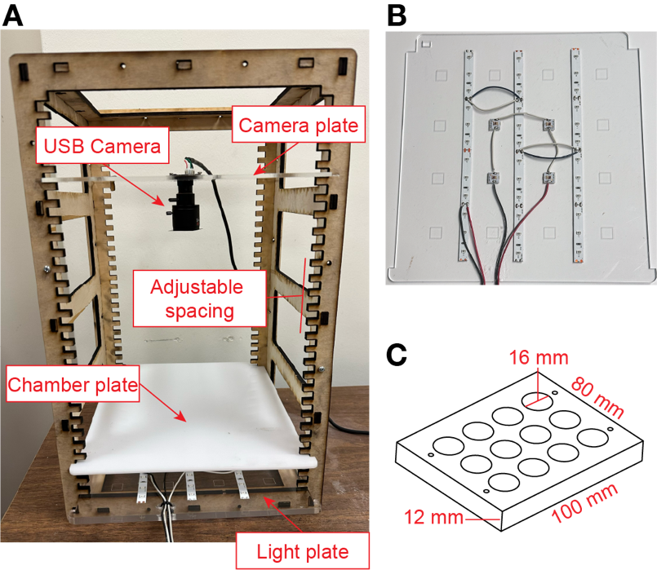
Figure 1. FlyRig experimental hardware. (A) Six laser-cut wood panels comprise the photostimulation frame. The rig contains a plate with the stimulation and infrared LEDs (light plate), a that diffuses light and holds the behavior chamber (diffuser plate), and a plate that holds the USB camera (camera plate). The relative placement of the plates can be easily adjusted in the frame. (B) The light plate contains four high-intensity LEDs for optogenetic stimulation wired in series and three infrared LED strips wired in parallel. (C) Schematic of acrylic behavioral chambers used for social behavior assays.
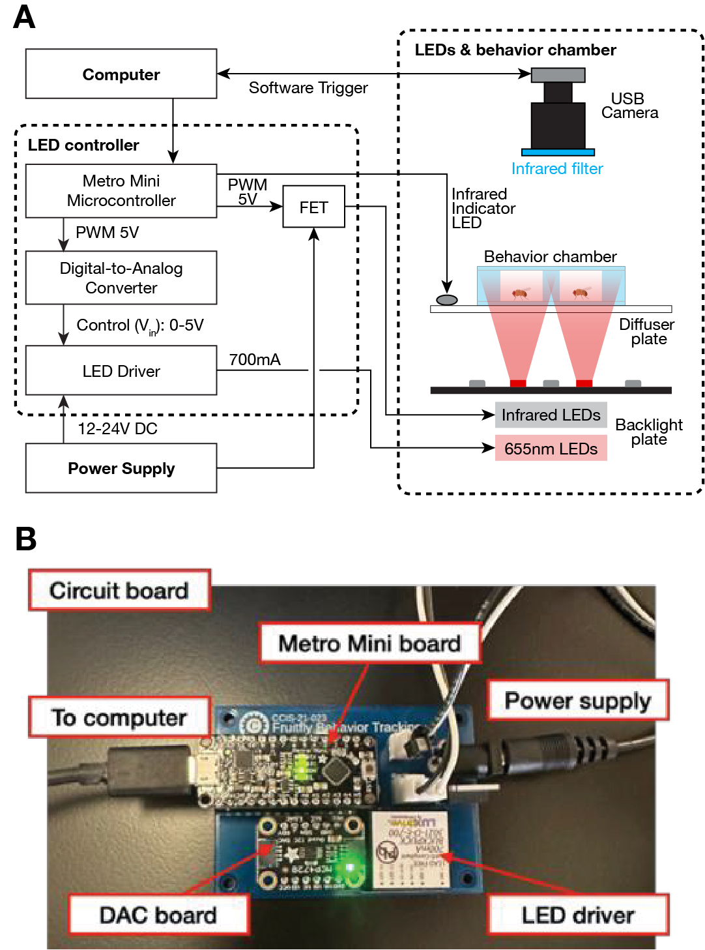

Figure 2. Light control board. (A) Schematic of light control and video recording circuit. (B) Assembled circuit board.

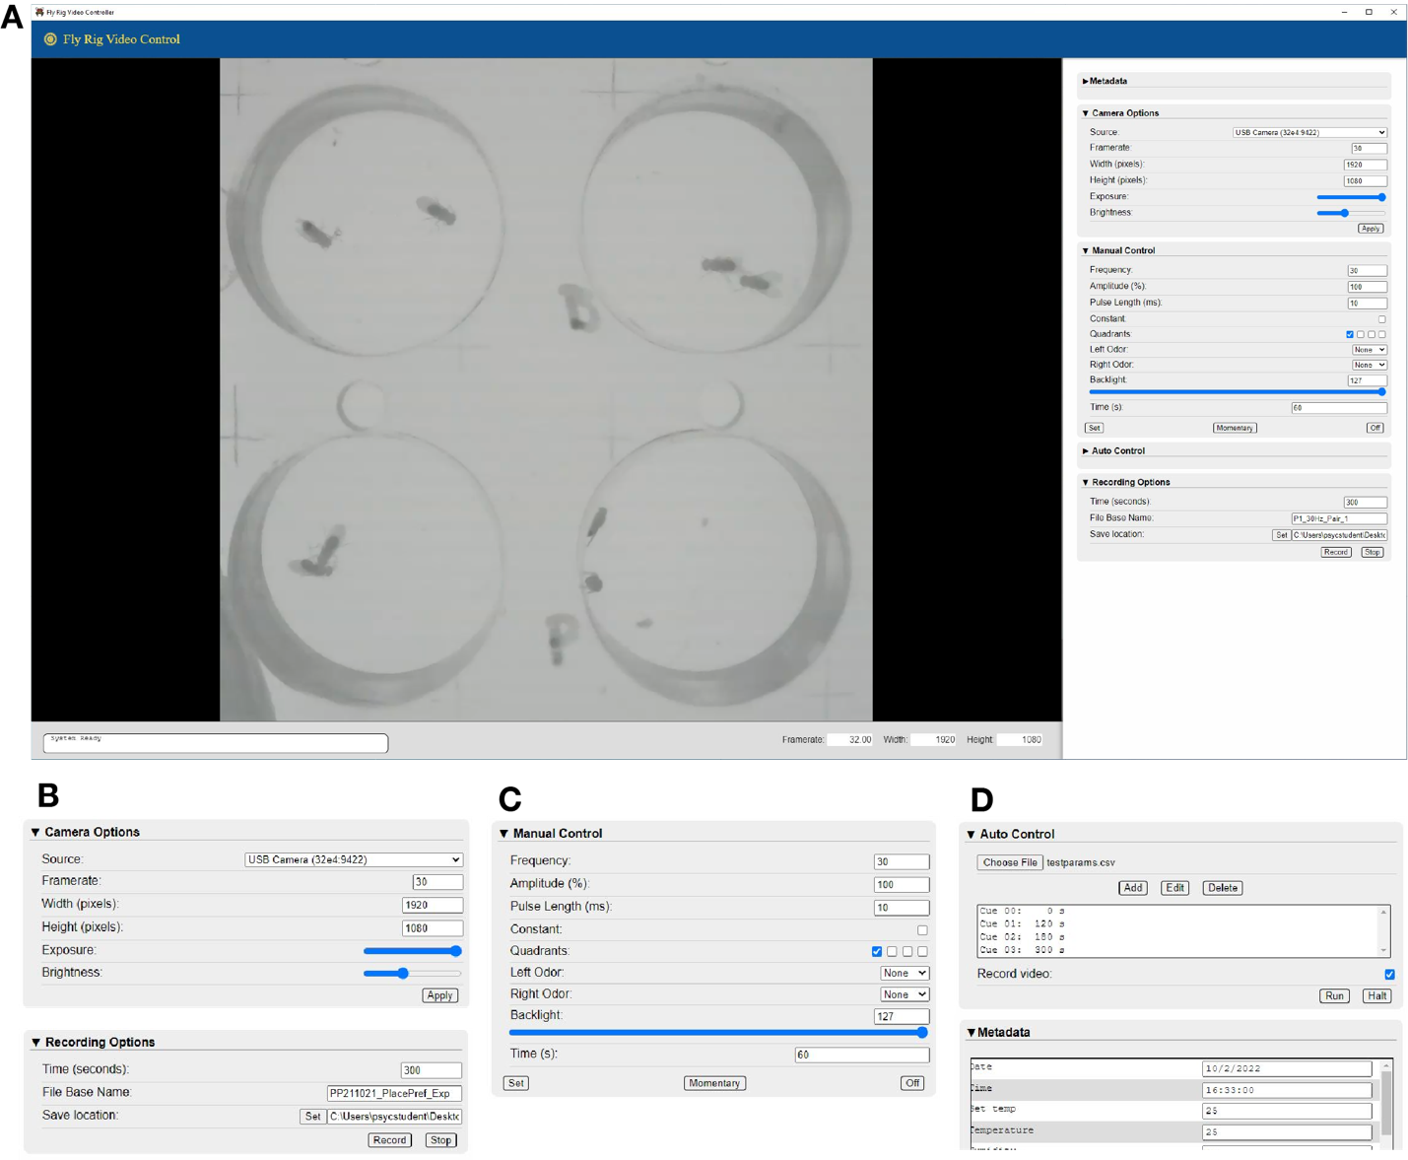
Figure 3. FlyRig Software. FlyRig software controls photostimulation and records videos of fly behavior. A central window provides a view of the recording. The camera resolution, frame rate, exposure, and brightness can be adjusted in the “Camera Options” window. The stimulation LED and infrared LEDs can be manually controlled in the “Manual Control” window. A set duration of light stimulation can be delivered with the “Set” button, or the user can momentarily turn on the light by clicking on the “Momentary” button. The “Auto Control” window allows users to create or upload a more complex sequence of light stimulations which is synchronized to the start of the video recording.

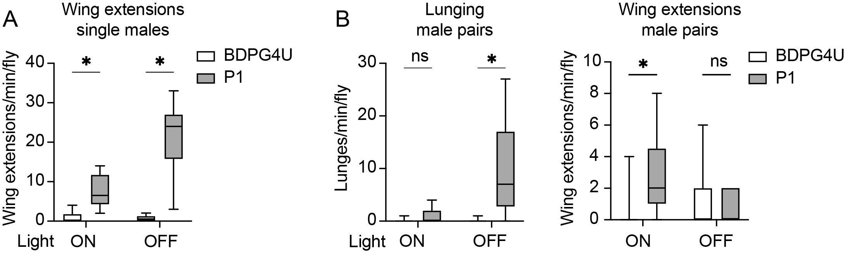
Figure 4. Automated behavior scores of student data from optogenetic activation of P1 neurons. Optogenetic stimulation of P1 neurons in male pairs promotes courtship during activation and aggression after. BDPG4U>CsChrimson (open bars) or P1ª>CsChrimson (filled bars) males were photostimulated for 1 minute with 655 nm light at 30 Hz, followed by 2 minutes of no light. (A) Frequency of wing extensions by solitary males during photostimulation (ON) and after photosimulation (OFF). n = 7 & 6 flies for BDPG4U & P1ª, respectively. (B) Frequency of lunging (left) and wing extensions (right) by pairs of males during and after photostimulation. n = 7 pairs for BDPG4U and P1ª. Boxplots show the median (line) and 25-75% of the data (box) with whiskers spanning 5-95% of the data. Asterisks represent p value < 0.05 from a Mann-Whitney U-test comparing BDPG4U and P1ª males.

Aggressive behaviors
Chasing | Male rapidly pursues the other fly.
Wing threat* | Male briefly charges forward with both wings thrust forward and raises its wings at a 45-degree angle.
Lunging* | Male rears up on its hind legs and snaps down onto the other fly.
Tussling/Boxing* | Two males rise onto their hind legs to grapple with each other and may box with their forelegs.
Courtship behaviors
Orienting & Following | Male orients its head towards the other fly and will start following it.
Tapping | Male extends a foreleg and touches the abdomen of the other fly.
Wing extension* (wing song) | Male extends one wing perpendicular to his body and circles around the other fly, while using the wing to produce courtship song.
Licking | Male extends its proboscis to touch the genitalia of the other fly.
Attempted Copulation* | Male will mount the other fly from behind, but falls off after a brief  time (seconds).
Copulation* | Mounting lasts for several minutes. Flies can move together as one.

Table 1 – Male aggression and courtship behaviors that students learned to identify. Behaviors with an asterisk were scored in example movies.

Question | Mean | SD
I am confident in my ability to explain how channelrhodopsin works to evoke action potentials. | 5.1 | ±0.7
I am confident in my ability to describe how the channelrhodopsin gene is expressed in specific neurons in fruit flies. | 4.9 | ±0.9
I am confident in my ability to formulate a hypothesis and design an experiment to test how neurons influence behavior. | 5.3 | ±0.8
I am confident in my ability to identify appropriate measures and controls for a behavioral experiment. | 5.1 | ±0.8
This lab increased my interest in neuroscience research. | 4.7 | ±1.3
It was easy to make a video recording using the FlyRig software. | 5.4 | ±0.6
It was easy to control the light stimulation using the FlyRig software. | 5.3 | ±0.7
The FlyRig software worked reliably. | 4.6 | ±1.3
Overall, using the FlyRig software to conduct an experiment was easy. | 5.0 | ±0.7

Table 2. Student evaluation of conceptual and technical aspects of the optogenetics laboratory. Student responses to queries ranked on a Likert scale (1 = Strongly Disagree, 2 = Disagree, 3 = Somewhat Disagree, 4 = Somewhat Agree, 5 = Agree, 6 = Strongly Agree). Mean and standard deviation of responses are shown. n = 17 students.

Anderson DJ (2016) Circuit modules linking internal states and social behaviour in flies and mice. Nature reviews Neuroscience 17:692–704 Available at: http://www.nature.com/nrn/journal/v17/n11/abs/nrn.2016.125.html?lang=en?WT.ec_id=NRN-201611&spMailingID=52555400&spUserID=MTc2ODI3OTIxMQS2&spJobID=1023457277&spReportId=MTAyMzQ1NzI3NwS2.
Anderson DJ, Adolphs R (2014) A framework for studying emotions across species. Cell 157:187–200.
Asahina K (2018) Sex differences in Drosophila behavior: Qualitative and Quantitative Dimorphism. Curr Opin Physiol 6:35–45.
Asahina K, Watanabe K, Duistermars BJ, Hoopfer E, González CR, Eyjólfsdóttir EA, Perona P, Anderson DJ (2014) Tachykinin-Expressing Neurons Control Male-Specific Aggressive Arousal in Drosophila. Cell 156:221–235 Available at: http://www.cell.com/abstract/S0092-8674(13)01536-5?utm_source=ECE001&utm_campaign=&utm_content=&utm_medium=email&bid=5LNUT5F.
Auer TO, Benton R (2016) Sexual circuitry in Drosophila. Current opinion in neurobiology 38:18–26 Available at: http://www.sciencedirect.com/science/article/pii/S0959438816000052.
Bath DE, Stowers JR, Hörmann D, Poehlmann A, Dickson BJ, Straw AD (2014) FlyMAD: rapid thermogenetic control of neuronal activity in freely walking Drosophila. Nature methods 11:756–762.
Berridge KC (2004) Motivation concepts in behavioral neuroscience. Physiology & behavior 81:179–209.
Boyden ES, Zhang F, Bamberg E, Nagel G, Deisseroth K (2005) Millisecond-timescale, genetically targeted optical control of neural activity. Nat Neurosci 8:1263–1268.
Brand AH, Perrimon N (1993) Targeted gene expression as a means of altering cell fates and generating dominant phenotypes. Development 118:401–415.
Branson K, Robie AA, Bender J, Perona P, Dickinson MH (2009) High-throughput ethomics in large groups of Drosophila. Nature methods Available at: http://www.nature.com/nmeth/journal/vaop/ncurrent/abs/nmeth.1328.html.
Chagas AM, Prieto-Godino LL, Arrenberg AB, Baden T (2017) The €100 lab: A 3D-printable open-source platform for fluorescence microscopy, optogenetics, and accurate temperature control during behaviour of zebrafish, Drosophila, and Caenorhabditis elegans. PLoS Biol 15:e2002702.
Chen S, Lee AY, Bowens NM, Huber R, Kravitz EA (2002) Fighting fruit flies: a model system for the study of aggression. Proceedings of the National Academy of Sciences of the United States of America 99:5664–5668 Available at: http://www.pnas.org/content/99/8/5664.
Chiu H, Hoopfer ED, Coughlan ML, Pavlou HJ, Goodwin SF, Anderson DJ (2021) A circuit logic for sexually shared and dimorphic aggressive behaviors in Drosophila. Cell 184:507-520.e16.
Chowdhury B, Wang M, Gnerer JP, Dierick HA (2021) The Divider Assay is a high-throughput pipeline for aggression analysis in Drosophila. Commun Biol 4:85.
Dankert H, Wang L, Hoopfer ED, Anderson DJ, Perona P (2009) Automated monitoring and analysis of social behavior in Drosophila. Nature methods 6:297–303.
Deisseroth K (2011) Optogenetics. Nat Methods 8:26–29.
Dionne H, Hibbard KL, Cavallaro A, Kao J-C, Rubin GM (2018) Genetic Reagents for Making Split-GAL4 Lines in Drosophila. Genetics 209:31–35.
Duistermars BJ, Pfeiffer BD, Hoopfer ED, Anderson DJ (2018) A Brain Module for Scalable Control of Complex, Multi-motor Threat Displays. Neuron 100:1474-1490.e4 Available at: https://www.sciencedirect.com/science/article/pii/S0896627318309358?via%3Dihub.
Eyjólfsdóttir E, Branson S, Burgos-Artizzu XP, Hoopfer ED, Schor J, Anderson DJ, Perona P (2014) Detecting Social Actions of Fruit Flies. In, pp 772–787 Computer Vision – ECCV 2014. Springer International Publishing. Available at: https://scholar.google.com/citations?view_op=view_citation&hl=en&user=ZW0IyX8AAAAJ&citation_for_view=ZW0IyX8AAAAJ:WF5omc3nYNoC.
Fenno L, Yizhar O, Deisseroth K (2011) The Development and Application of Optogenetics. Neuroscience 34:389–412.
Fu Z, Huda A, Kimbrough IF, Ni L (2023) Using Drosophila Two-Choice Assay to Study Optogenetics in Hands-On Neurobiology Laboratory Activities. J Undergrad Neurosci Educ 22:A45–A50.
Hall JC (1994) The Mating of a Fly. Science 264:1702–1714.
Hoopfer ED (2016) Neural control of aggression in Drosophila. Current opinion in neurobiology 38:109–118.
Hoopfer ED, Jung Y, Inagaki HK, Rubin GM, Anderson DJ (2015) P1 interneurons promote a persistent internal state that enhances inter-male aggression in Drosophila Ramaswami M, ed. Elife 4:e11346.
Inagaki HK, Jung Y, Hoopfer ED, Wong AM, Mishra N, Lin JY, Tsien RY, Anderson DJ (2013) Optogenetic control of Drosophila using a red-shifted channelrhodopsin reveals experience-dependent influences on courtship. Nature methods Available at: http://www.nature.com/nmeth/journal/vaop/ncurrent/full/nmeth.2765.html.
Inagaki HK, Panse KM, Anderson DJ (2014) Independent, reciprocal neuromodulatory control of sweet and bitter taste sensitivity during starvation in Drosophila. Neuron 84:806–820.
Jenett A et al. (2012) A GAL4-driver line resource for Drosophila neurobiology. Cell reports 2:991–1001.
Jung Y, Kennedy A, Chiu H, Mohammad F, Claridge-Chang A, Anderson DJ (2020) Neurons that Function within an Integrator to Promote a Persistent Behavioral State in Drosophila. Neuron 105:322-333.e5.
Kabra M, Robie AA, Rivera-Alba M, Branson S, Branson K (2013) JAABA: interactive machine learning for automatic annotation of animal behavior. Nature methods 10:64–67.
Kennedy A, Asahina K, Hoopfer E, Inagaki H, Jung Y, Lee H, Remedios R, Anderson DJ (2014) Internal States and Behavioral Decision-Making: Toward an Integration of Emotion and Cognition. Cold Spring Harbor Symposia on Quantitative Biology 79:199–210 Available at: http://symposium.cshlp.org/content/79/199.long.
Klapoetke NC et al. (2014) Independent optical excitation of distinct neural populations. Nature methods 11:338–346 Available at: http://www.nature.com/doifinder/10.1038/nmeth.2836.
Lee SS, Wu MN (2020) Neural circuit mechanisms encoding motivational states in Drosophila. Curr Opin Neurobiol 64:135–142.
Lim RS, Eyjólfsdóttir E, Shin E, Perona P, Anderson DJ (2014) How food controls aggression in Drosophila. Louis M, ed. PLoS ONE 9:e105626.
Mohammad F, Stewart JC, Ott S, Chlebikova K, Chua JY, Koh T-W, Ho J, Claridge-Chang A (2017) Optogenetic inhibition of behavior with anion channelrhodopsins. Nat Methods 14:271–274.
Nagel G, Szellas T, Huhn W, Kateriya S, Adeishvili N, Berthold P, Ollig D, Hegemann P, Bamberg E (2003) Channelrhodopsin-2, a directly light-gated cation-selective membrane channel. Proc Natl Acad Sci 100:13940–13945.
Oren-Suissa M, Shirangi TR (2025) Neural Circuits Underlying Sexually Dimorphic Innate Behaviors. Annu Rev Neurosci 48:191–210.
Palavicino-Maggio CB, Chan Y-B, McKellar C, Kravitz EA (2019) A small number of cholinergic neurons mediate hyperaggression in female Drosophila. Proc Natl Acad Sci 116:17029–17038.
Pan Y, Robinett CC, Baker BS (2011) Turning males on: activation of male courtship behavior in Drosophila melanogaster. Brembs B, ed. PLoS ONE 6:e21144.
Pereira TD, Aldarondo DE, Willmore L, Kislin M, Wang SS-H, Murthy M, Shaevitz JW (2019) Fast animal pose estimation using deep neural networks. Nat Methods 16:117–125.
Pfeiffer BD, Ngo T-TB, Hibbard KL, Murphy C, Jenett A, Truman JW, Rubin GM (2010) Refinement of tools for targeted gene expression in Drosophila. Genetics 186:735–755.
Pulver SR, Hornstein NJ, Land BL, Johnson BR (2011) Optogenetics in the teaching laboratory: using channelrhodopsin-2 to study the neural basis of behavior and synaptic physiology in Drosophila. Advances in Physiology Education 35:82–91 Available at: https://www.physiology.org/doi/full/10.1152/advan.00125.2010.
Pulver SR, Pashkovski SL, Hornstein NJ, Garrity PA, Griffith LC (2009) Temporal Dynamics of Neuronal Activation by Channelrhodopsin-2 and TRPA1 Determine Behavioral Output in Drosophila Larvae. J Neurophysiol 101:3075–3088.
Robie AA, Hirokawa J, Edwards AW, Umayam LA, Lee A, Phillips ML, Card GM, Korff W, Rubin GM, Simpson JH, Reiser MB, Branson K (2017) Mapping the Neural Substrates of Behavior. Cell 170:393-406.e28.
Rodriguez A, Zhang H, Klaminder J, Brodin T, Andersson PL, Andersson M (2018) ToxTrac: A fast and robust software for tracking organisms. Methods Ecol Evol 9:460–464.
Schretter CE (2025) Aggression across sexes from a contextual- and circuit-based perspective. Curr Opin Neurobiol 93:103071.
Shao L, Saver M, Chung P, Ren Q, Lee T, Kent CF, Heberlein U (2017) Dissection of the Drosophila neuropeptide F circuit using a high-throughput two-choice assay. Proceedings of the National Academy of Sciences of the United States of America 114:E8091–E8099.
Tadres D, Louis M (2020) PiVR: An affordable and versatile closed-loop platform to study unrestrained sensorimotor behavior. PLoS Biol 18:e3000712.
Titlow JS, Johnson BR, Pulver SR (2015) Light Activated Escape Circuits: A Behavior and Neurophysiology Lab Module using Drosophila Optogenetics. J Undergrad Neurosci Educ : JUNE : a Publ FUN, Fac Undergrad Neurosci 13:A166-73.
Vilinsky I, Hibbard KL, Johnson BR, Deitcher DL (2018) Probing Synaptic Transmission and Behavior in Drosophila with Optogenetics: A Laboratory Exercise. J Undergrad Neurosci Educ : JUNE : a Publ FUN, Fac Undergrad Neurosci 16:A289–A295.
Yadav RSP, Dey P, Ansari F, Kottat T, Prabhu PP, Vasam M, Ayyangar S, S SB, Prabhu K, Ghosh M, Agrawal P (2025) DANCE: An open-source analysis pipeline and low-cost hardware to quantify aggression and courtship in Drosophila.

